**KUBERNETES[TASK-05]**

1) Create a namespace dev-environment and apply a resource-based quota that restricts the number of pods to 3 and services to 2.

Created a namespace

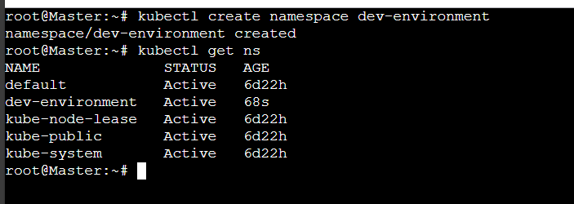

Creating a resource based quota

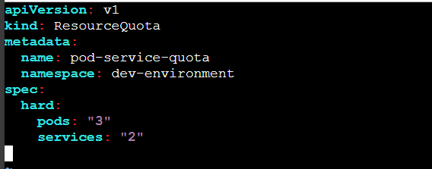



Output



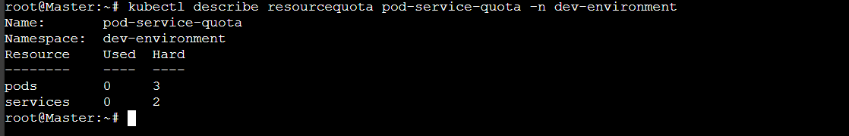

2) Create a pod in the prod-environment namespace with 0.2 CPU and 200Mi memory requests, and 0.5 CPU and 500Mi memory limits.

Created a namespace “prod-environment”

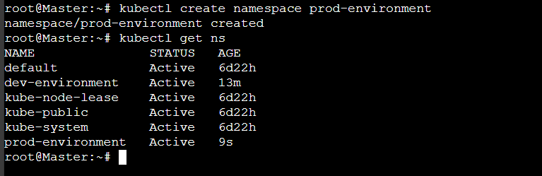

Created a namespace1.yaml file

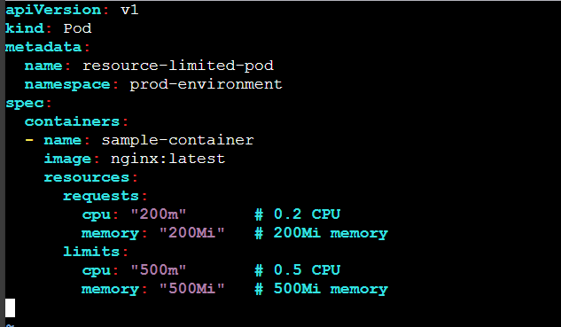

Now,

“kubectl apply -f namespace1.yaml”



Using “kubectl describe pod resource-limited-pod -n prod-environment”

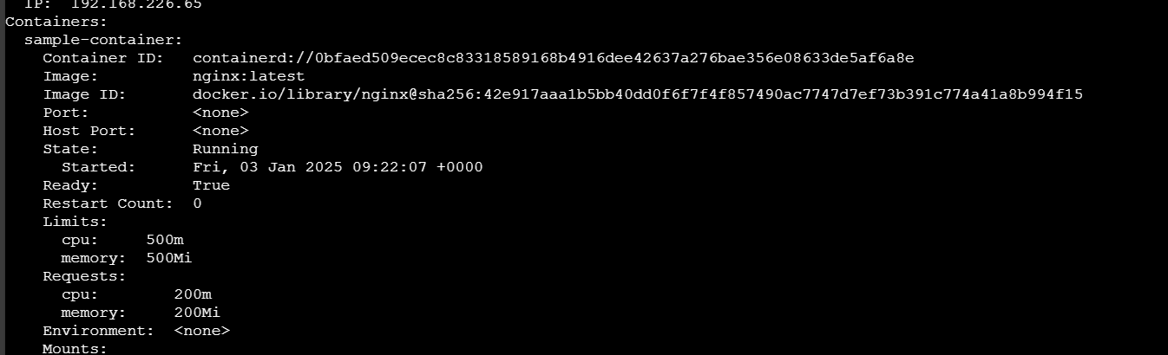

3) In the staging-environment namespace, set a LimitRange that assigns default CPU and memory limits (300m CPU, 600Mi memory) and applies a minimum and maximum CPU.

Created a namespace “staging-environment”

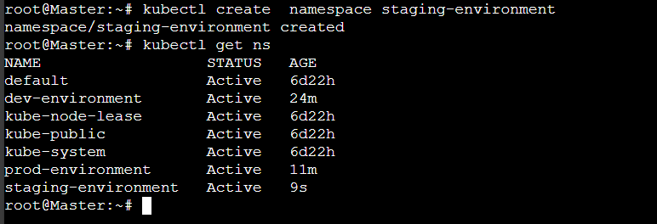

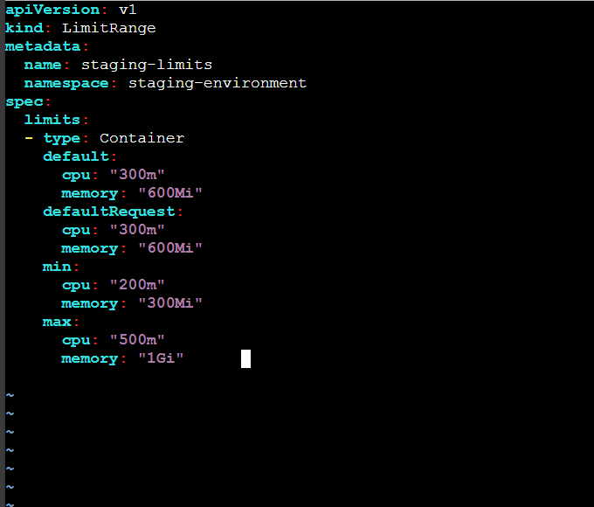

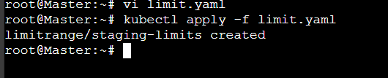

Using

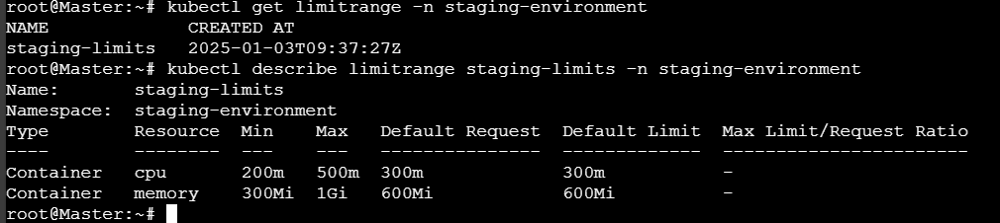

4) Create a pod and a NodePort service in the default namespace, then create another pod in the test namespace and communicate between them using Service DNS.

Created a pod and a nodeport service in default namespace

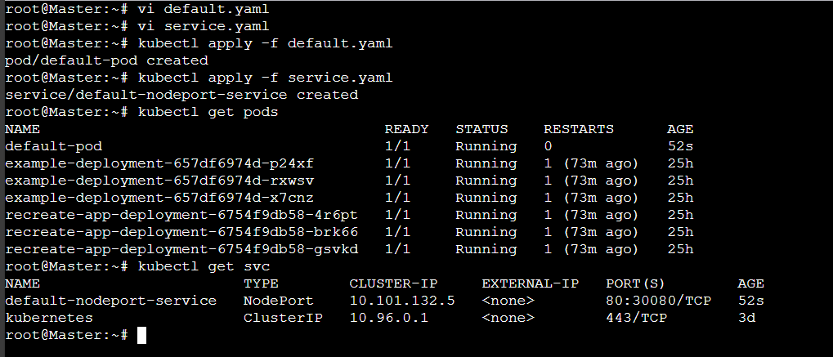

Created a namespace with test

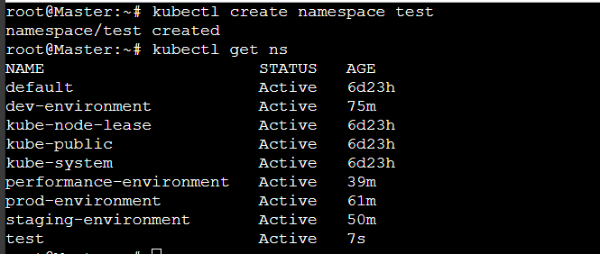

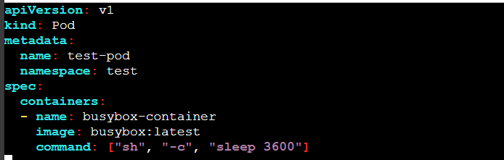

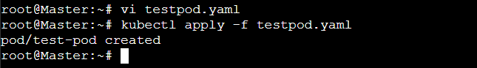

5) Apply a LimitRange with a max limit/request ratio of 2 for memory in the performance-environment namespace, and test by creating a pod with mismatched resource requests and limits.

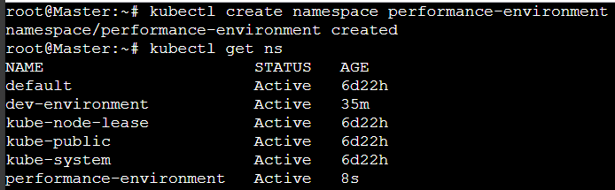

Created a sample.yaml file

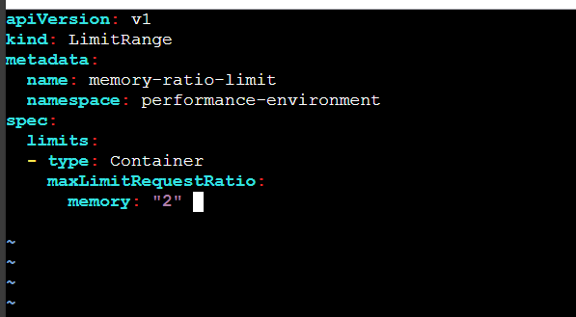

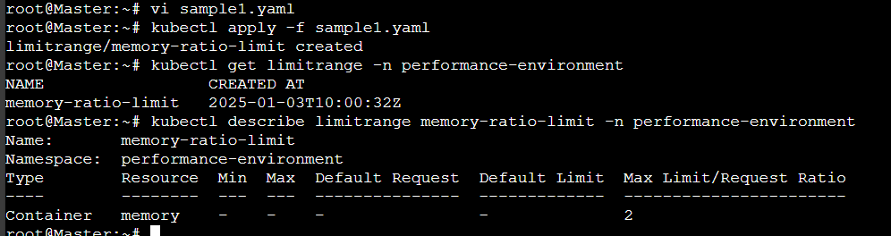

test by creating a pod with mismatched resource requests and limits.

